SHRI RAMDEOBABA COLLEGE OF ENGINEERING AND MANAGEMENT, NAGPUR.



ELECTRONIC WORKSHOP LAB

MINI PROJECT REPORT

(6TH SEM, SESSION 2019-2020, ECP310)

“RFID AND KEYPAD BASED SECURITY SYSTEM”

Submitted By

PUSHKAR RATHI (Roll No.-77, Sec-B)
VEDANT KOTHARI (Roll No.-88, Sec-B)
PRATHAMESH IYER (Roll No.-94, Sec-B)

Department of Electronics and Communication Engineering

- Introduction
In this project, we are going to develop an RFID and keypad based Security system. This project is implemented by using 8051 microcontroller.

Using this system, authorization of personnel is carried out with an RFID card and only those with access can enter a secured area.This project deals with an interesting manner of security access control with the help of RFID Technology, where only people with valid cards are allowed to access the door or any secure area.

- Block diagram and Functional description
The complete security system can be divided into various sections -Reader section, Keypad, Control section, Driver section and Display section.

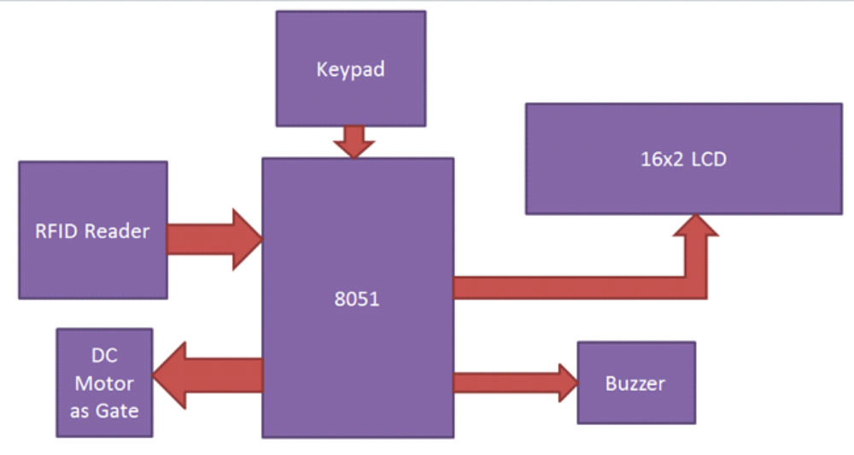

Reader Section: This section contains a RFID, which is an electronics device which has two parts - one is RFID Reader and other is RFID tag or Card. When we put RFID tag near the RFID reader it reads tag data serially.

Keypad: Here we have used a 4x3 matrix keypad for entering the password to the system.

Control Section: 8051 microcontroller is used for controlling the complete process of this RFID based security system. Here by using 8051 we are receiving RFID data and sending status or messages to LCD.

Display Section: 16x2 LCD is used in this project for displaying messages on it.

Driver Section: This section has a motor driver L293D for opening gate.

- Circuit diagram and its description:

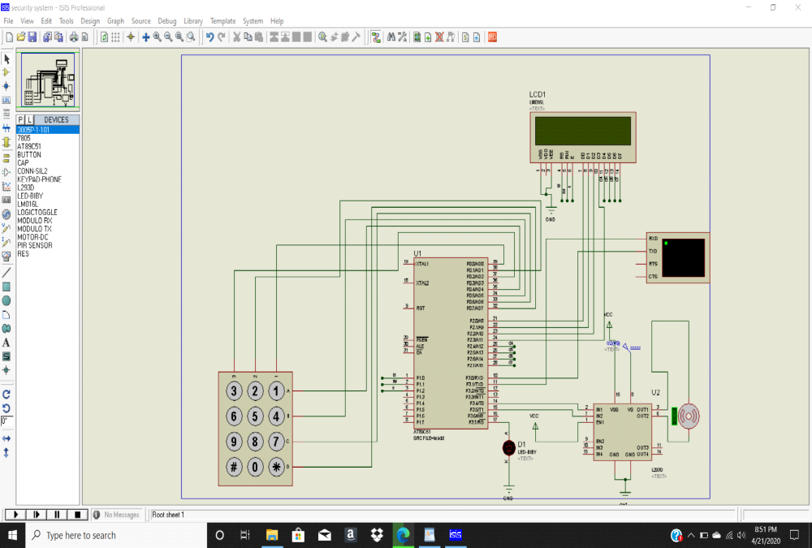

As shown in above RFID security system circuit diagram, 16x2 LCD is connected in four bit mode with microcontroller. LCD’s RS, RW and EN pins are directly connected at PORT 1 pin number P1.0, P1.1 and P1.2. The eight data lines are directly connected to port2. Motor driver is connected at port pin number P3.4 and P3.5. And keypad is connected at PORT0. Keypad row are connected at P0.4 – P0.7 and Columns are connected at P0.0 – P0.2.

Microcontroller AT89C51(8051): It is an 8-bit microcontroller. It is built with 40 pins DIP (dual inline package), 4kb of ROM storage and 128 bytes of RAM storage, 2 16-bit timers. It consists of are four parallel 8-bit ports, which are programmable as well as addressable as per the requirement.

- PCB layout and Artwork

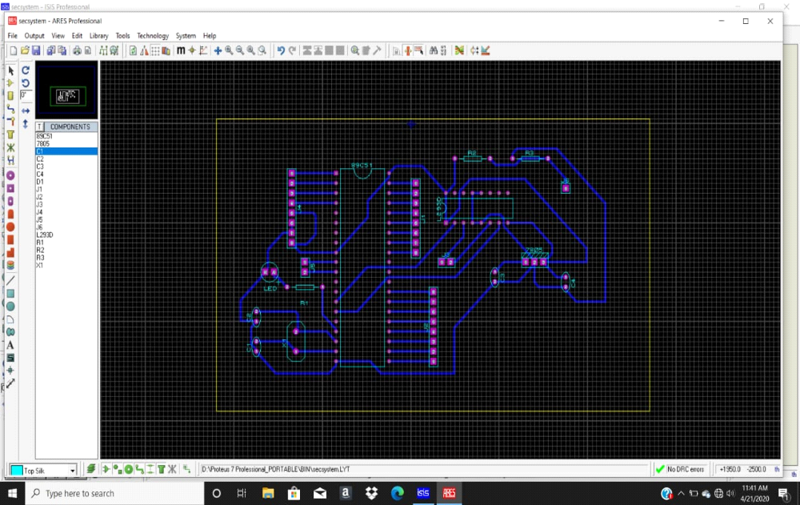

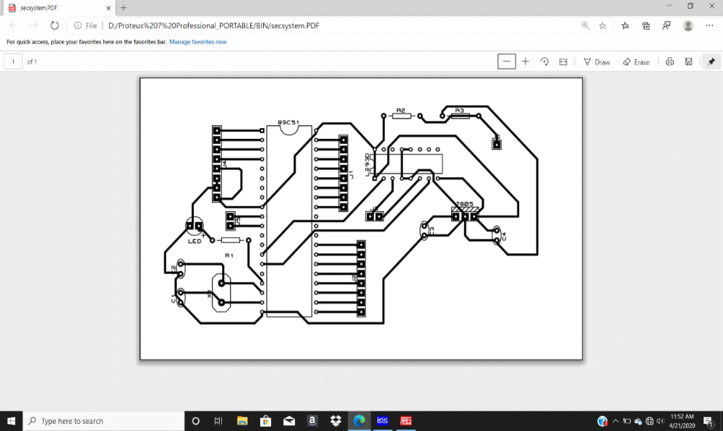

- Working of Project:

When someone put their RFID tag over RFID reader then RFID reads tag’s data and ship to 8051 microcontroller after it, microcontroller compares this received data with predefined data or records. If data is matched with predefined data or records then microcontroller ask for password and after coming password into microcontroller it starts to examine password with predefined password. If password is correct then the Door Motor rotates in forward direction to open the door. After a delay of 3 seconds, the microcontroller makes P0.0 LOW and P0.1 HIGH, so the motor driver gets the input signals for reverse motion. As a result, the Door motor rotates in reverse direction to close the door.

If the password is not matched, then microcontroller maintains both P0.0 and P0.1 LOW. Hence, the door motor is stationary so that door remains closed liquid crystal display will display access denied and buzzer begin beeping for a while.
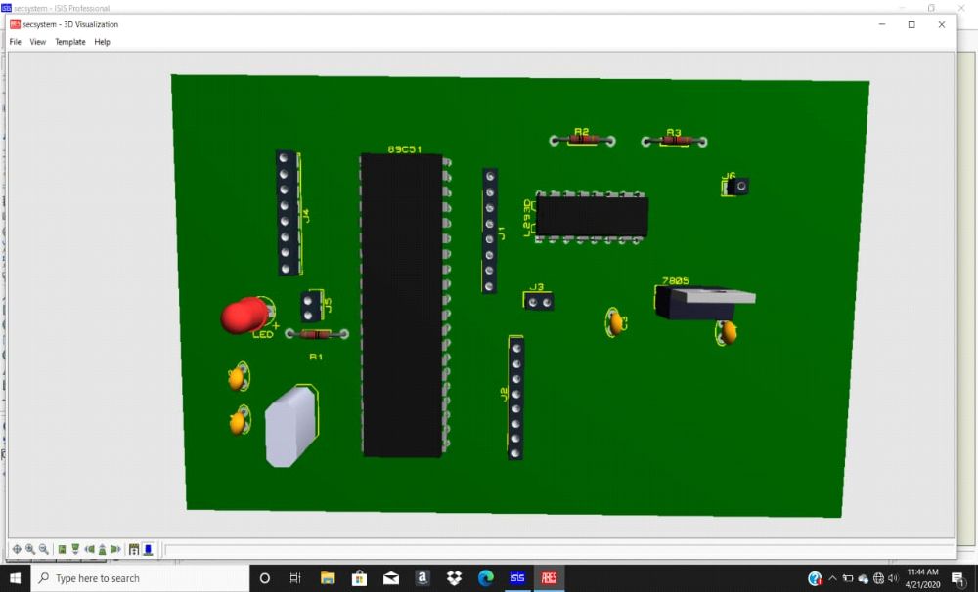

- Result and Future Scope

Advantages: RFID based Security Access System is designed in this project. As the system uses RFID Technology based identification, it can be used to access secured areas like research centres, defence sites etc.

Limitations: It is a low range circuit, i.e. it is not possible to operate the circuit remotely.
If we forget the password, it is not possible to open the door.

Applications: This project can be used in schools, colleges, office and stations for various purposes to automatically authenticate people with valid RFID tags.

Future Development: We can add multiple layers of security like Bluetooth , GSM , Fingerprint.

